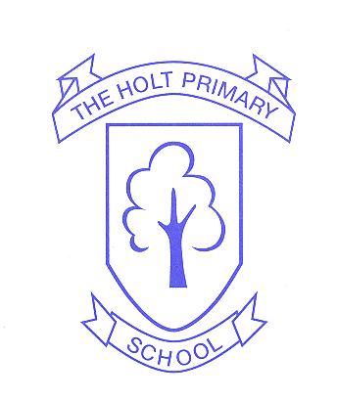

Geography
At The Holt Primary School
2022-2023

Contents
Aims of geography at The Holt Primary School………………………………………………………………..…………2
Objectives…………………………………………………………….………...2
Curriculum map…………………………………………………………………3
EYFS…………………………………………………………………………….4
National Curriculum Coverage………………………………………………….5
Stand development across The Holt Primary School…………………………..9
Knowledge organisers………………………………………………..……….14
Links to English and Maths……………………………………………………17
Assessment……………………………………………………………………18
Outdoor education………………………………………………………….….18

Aims of geography at The Holt
At The Holt Primary School the aims of geography are to teach our children an understanding of places and environments.
Through their work in Geography, our children learn about their local area and compare their life with that of other regions of the United Kingdom and the rest of the world.
They learn how to draw and interpret maps and they develop the skills of research, investigation, analysis and problem solving. Through their growing knowledge and understanding of human geography out children gain an appreciation of life in other cultures.
Our geography teaching also motivates children to find out about the physical world and enables them to recognise the importance of sustainable development for the future of mankind.
Objectives
- To provide a range of geographical experiences, both in and out of the classroom, which encourage children to build interest and enjoyment, knowledge, understanding and confidence, as well as allowing them to achieve the maximum potential in the subject.
- To foster a sense of wonder and curiosity about the world in which they live and develop a sense of place.
- To develop their geographical vocabulary and a range of skills and apply them in a increasing range of situations to carry out geographical enquiry and to interpret geographical information.
- To communicate geographical information in a variety of ways.
- To become familiar with their own surroundings and extent their interest, knowledge and understanding of contrasting localities in Britain, Europe and the wider world.
- To develop knowledge and understanding of the human and physical processes and patterns which shape places and extend this to an appreciation of interconnections within and between different places.
- To adopt an enquiring approach to the world around them, developing in their ability to formulate appropriate questions, research, handle data and draw conclusions.
- To appreciate similarity and difference in the world around them, having empathy for the lives of others and respect for other’s beliefs, attitudes and values.
- To enhance their sense of responsibility for the care of the earth and its people.
- To develop a simple understanding of environmental sustainability and how they can be actively involved in living as sustainably as possible.

Curriculum map
 | Term 1 | Term 2 | Term 3 | Term 4 | Term 5 | Term 6
Rec |  |  |  | Into the Woods |  | Ahoy Maties
Year 1 |  |  |  |  | Wonderful Weather
Year 2 |  |  |  |  |  | Life in Japan
Year 3/4 cycle A |  |  |  |  |  | Planes, trains and automobiles
Year 3/4 cycle B | Rotten Romans |  | Fragile Earth |  | Walk like an Egyptian
Year 5/6 cycle A | Passport to the world | Rumble in the Jungle |  |  | The athlete
Year 5/6 cycle B |  |  | Land before time

EYFS
In our Reception class, children will be introduced to geography through exploring the world around them. We understand that children learn best when they are absorbed, interested and active. We understand that active learning involves other children, adults, objects, ideas, stimuli and events that aim to engage and involve children for sustains periods.
The EYFS framework is structured differently to the national curriculum. It is organised across seven areas of learning rather than subject areas.
The most relevant statements are taken from the Understanding the world area of learning.
People Culture and Communities | - Describe their immediate environment using knowledge from observation, discussion, stories, non-fiction texts, and maps.  - Know some similarities and differences between different religious and cultural communities in this country, drawing on their experiences and what has been read in class.  - Explain some similarities and differences between life in this country and life in other countries, drawing on knowledge from stories, non-fiction texts and – when appropriate – maps.
The Natural World ELG | - Know some similarities and differences between the natural world around them and contrasting environments, drawing on their experiences and what has been read in class.  - Understand some important processes and changes in the natural world around them, including the seasons and changing states of matter.

National Curriculum Coverage

THE HOLT PRIMARY SCHOOL GEOGRAPHY FRAMEWORK
 | Year 1 | Year 2 | Year3 | Year 4 | Year 5 | Year 6
Locational Knowledge | WONDERFUL WEATHER TERM 5  Name, locate and identify characteristics of the four countries and capital cities of the United Kingdom and its surrounding seas. | LIFE IN JAPAN TERM 6  Name and locate the world’s seven continents and five oceans. | CYCLE B – THE ROTTEN ROMANS – TERM 1 & 2  Locate and name the main counties and cities in the united Kingdom, geographical regions and their identifying human and physical characteristics |  | CYCLE A – PASSPORT TO THE WORD TERM 1  name and locate counties and cities of the United Kingdom, geographical regions and their identifying human and physical characteristics, key topographical features (including hills, mountains, coasts and rivers), and land-use patterns; and understand how some of these aspects have changed over time  CYCLE A – RUMBLE IN THE JUNGLE TERM 2  identify the position and significance of latitude, longitude, Equator, Northern Hemisphere, Southern Hemisphere, the Tropics of Cancer and Capricorn, Arctic and Antarctic Circle, the Prime/Greenwich Meridian and time zones (including day and night)  locate the world’s countries, using maps to focus on Europe (including the location of Russia) and North and South America, concentrating on their environmental regions, key physical and human characteristics, countries, and major cities
Place Knowledge |  | LIFE IN JAPANTERM 6  Understand geographical similarities and differences through studying the human and physical geography of a small area of the United Kingdom, and of a small area in a contrasting non-European Country |  |  | CYCLE A – RUMBLE IN THE JUNGLE TERM 2  understand geographical similarities and differences through the study of human and physical geography of a region of the United Kingdom, a region in a European country, and a region within North or South America
Human &Physical Geography | WONDERFUL WEATHER TERM 5  Identify seasonal and daily weather patterns in the United Kingdom.  Identify the location of hot and cold areas of the world in relation to the Equator and the North and South Poles  Use basic geographical vocabulary to refer to:  - key physical features, including:, forest, hill, mountain, soil, valley, vegetation,.  - key human features, including: city, town, village, factory, farm, house, office. | LIGFE IN JAPAN TERM 6  Use basic geographical vocabulary to refer to:  - key physical features, including: beach, cliff, coast, forest, hill, mountain, sea, ocean, river, soil, valley, vegetation, season and weather  - key human features, including: city, town, village, factory, farm, house, office, port, harbour and shop | CYCLE B – FRAGILE EARTH – TERM 3 & 4  Describe and understand key aspects of physical geography, including: rivers, mountains, volcanoes and earthquakes, and the water cycle  CYCLE B – WALK LIKE AN EGYPTION – TERM 6  human geography, including: types of settlement and land use, economic activity including trade links, and the distribution of natural resources including energy, food, minerals and water |  | CYCLE A – RUMBLE IN THE JUNGLE TERM 2  Describe and understand key aspects of physical geography, including: climate zones, biomes and vegetation belts,  CYCLE A – THE ATHLETE  human geography, including: types of settlement and land use, economic activity including trade links, and the distribution of natural resources including energy, food, minerals and water
Geographical skills and Fieldwork | Pupils should be taught to:  • use world maps, atlases and globes to identify the United Kingdom and its countries, as well as the countries, continents and oceans studied at this key stage  • use simple compass directions (North, South, East and West) and locational and directional language [for example, near and far; left and right], to describe the location of features and routes on a map  • use aerial photographs and plan perspectives to recognise landmarks and basic human and physical features; devise a simple map; and use and construct basic symbols in a key  • use simple fieldwork and observational skills to study the geography of their school and its grounds and the key human and physical features of its surrounding environment |  | Pupils should be taught to:  • use maps, atlases, globes and digital/computer mapping to locate countries and describe features studied  • use the eight points of a compass, four and six-figure grid references, symbols and key (including the use of Ordnance Survey maps) to build their knowledge of the United Kingdom and the wider world  • use fieldwork to observe, measure, record and present the human and physical features in the local area using a range of methods, including sketch maps, plans and graphs, and digital technologies
Geographical skills and Fieldwork  Fieldwork | For instance:  Gather information  Use basic observational skills  Carry out a small survey of the local area/school  Draw simple features  Ask and respond to basic geographical questions  Ask a familiar person prepared questions  Use a pro-forma to collect data e.g. tally survey  Sketching  Create plans and raw simple features in their familiar environment  Add labels onto a sketch map, map or photograph of features  Audio/Visual  Recognise a photo or a video as a record of what has been seen or heard  Use a camera in the field to help to record what is seen |  | For instance:  Gather information  Ask geographical questions  Use a simple database to present findings from fieldwork  Record findings from fieldtrips  Use a database to present findings  Use appropriate terminology  Sketching  Draw an annotated sketch from observation including descriptive / explanatory labels and indicating direction  Audio/Visual  Select views to photograph  Add titles and labels giving date and location information  Consider how photo’s provide useful evidence use a camera independently  Locate position of a photo on a map |  | For instance:  Gather information  Select appropriate methods for data collection such as interviews,  Use a database to interrogate/amend information collected,  Use graphs to display data collected  Evaluate the quality of evidence collected and suggest improvements  Sketching  Evaluate their sketch against set criteria and improve it  Use sketches as evidence in an investigation. select field sketching from a variety of techniques  Annotate sketches to describe and explain geographical processes and patterns  Audio/Visual  Make a judgement about the best angle or viewpoint when taking an image or completing a sketch  Use photographic evidence in their investigations  Evaluate the usefulness of the images
Geographical skills and Fieldwork  Map skills | For instance:  Using maps  Use a simple picture map to move around the school  Use relative vocabulary such as bigger, smaller, like, dislike  Use directional language such as near and far, up and down, left and right, forwards and backwards  Map knowledge  Use world maps to identify the UK in its position in the world.  Use maps to locate the four countries and capital cities of UK and its surrounding seas  Making maps  Draw basic maps, including appropriate symbols and pictures to represent places or features  Use photographs and maps to identify features | For instance:  Using maps  Follow a route on a map with some accuracy  Locate places using a range of maps including OS & digital  Begin to match boundaries (e.g. find same boundary of a country on different scale maps)  Use 4 figure compasses, and letter/number co-ordinates to identify features on a map  Map knowledge  Locate the UK on a variety of different scale maps  Name & locate the counties and cities of the UK  Making maps  Try to make a map of a short route experiences, with features in current order  Create a simple scale drawing  Use standard symbols, and understand the importance of a key | For instance:  Using maps  Compare maps with aerial photographs  Select a map for a specific purpose  Begin to use atlases to find out other information (e.g. temperature)  Find and recognise places on maps of different scales  Use 8 figure compasses, begin to use 6 figure grid references.  Map knowledge  Locate the world’s countries, focus on North & South America  Identify the position and significance of lines of longitude & latitude  Making maps  Draw a variety of thematic maps based on their own data  Draw a sketch map using symbols and a key,  Use and recognise OS map symbols regularly | For instance:  Using maps  Follow a route on a map  Use simple compass directions (North, South, East, West)  Use aerial photographs and plan perspectives to recognise landmarks and basic human and physical features  Map knowledge  Locate and name on a world map and globe the seven continents and five oceans.  Locate on a globe and world map the hot and cold areas of the world including the Equator and the North and South Poles  Making maps  Draw or make a map of real or imaginary places (e.g. add detail to a sketch map from aerial photograph)  Use and construct basic symbols in a key | For instance:  Using maps  Follow a route on a large scale map  Locate places on a range of maps (variety of scales)  Identify features on an aerial photograph, digital or computer map  Begin to use 8 figure compass and four figure grid references to identify features on a map  Map knowledge  Locate Europe on a large scale map or globe,  Name and locate countries in Europe (including Russia) and their capitals cities  Making maps  Recognise and use OS map symbols, including completion of a key and understanding why it is important  Draw a sketch map from a high viewpoint | For instance:  Using maps  Follow a short route on a OS map  Describe the features shown on an OS map  Use atlases to find out data about other places  Use 8 figure compass and 6 figure grid reference accurately  Use lines of longitude and latitude on maps  Map knowledge  Locate the world’s countries on a variety of maps, including the areas studied throughout the Key Stages  Making maps  Draw plans of increasing complexity  Begin to use and recognise atlas symbols

Strand development across The Holt Primary School

 | Geographical enquiry
Year 1 | - Teacher led enquiries, to ask and respond to simple closed questions.  - Use information books/pictures as sources of information.  - Investigate their surroundings Make observations about where things are e.g. within school or local area.
Year 2 | - Children encouraged to ask simple geographical questions, Where is it? What's it like?  - Use NF books, stories, maps, pictures/photos and internet as sources of information.  - Investigate their surroundings  - Make appropriate observations about why things happen.  - Make simple comparisons between features of different places.
Year 3 | - Begin to ask/initiate geographical questions.  - Use NF books, stories, atlases, pictures/photos and internet as sources of information.  - Investigate places and themes at more than one scale  - Begin to collect and record evidence  - Analyse evidence and begin to draw conclusions e.g. make comparisons between two locations using photos/ pictures, temperatures in different locations.
Year 4 | - Ask and respond to questions and offer their own ideas.  - Extend to satellite images, aerial photographs  - Investigate places and themes at more than one scale  - Collect and record evidence with some aid  - Analyse evidence and draw conclusions e.g. make comparisons between locations photos/pictures/ maps
Year 5 | - Begin to suggest questions for investigating  - Begin to use primary and secondary sources of evidence in their investigations.  - Investigate places with more emphasis on the larger scale; contrasting and distant places  - Collect and record evidence unaided  - Analyse evidence and draw conclusions e.g. compare historical maps of varying scales e.g. temperature of various locations - influence on people/everyday life
Year 6 | - Suggest questions for investigating  - Use primary and secondary sources of evidence in their investigations.  - Investigate places with more emphasis on the larger scale; contrasting and distant places  - Collect and record evidence unaided  - Analyse evidence and draw conclusions e.g. from field work data on land use  comparing land use/temperature, look at patterns and explain reasons behind it
 | Direction/Location
Year 1 | • Follow directions (Up, down, left/right, forwards/backwards)
Year 2 | • Follow directions (as yr 1 and inc’. NSEW)
Year 3 | • Use 4 compass points to follow/give directions:  • Use letter/no. co-ordinates to locate features on a map.
Year 4 | • Use 4 compass points well  • Begin to use 8 compass points  • Use letter/no. co-ordinates to locate features on a map confidently.
Year 5 | • Use 8 compass points  • Begin to use 4 figure co-ordinates to locate features on a map.
Year 6 | • Use 8 compass points confidently and accurately.  • Use 4 figure co-ordinates confidently to locate features on a map.  • Begin to use 6 figure grid refs; use latitude and longitude on atlas

 | Drawing maps
Year 1 | • Draw picture maps of imaginary places and from stories.
Year 2 | • Draw a map of a real or imaginary place. (e.g. add detail to a sketch  map from aerial photograph).
Year 3 | • Try to make a map of a short route experienced, with features in  correct order.  • Try to make a simple scale drawing.
Year 4 | • Make a map of a short route experienced, with features in correct  order.  • Make a simple scale drawing.
Year 5 | • Begin to draw a variety of thematic maps based on their own data.
Year 6 | • Draw a variety of thematic maps based on their own data.  • Begin to draw plans of increasing complexity.

 | Representations
Year 1 | • Use own symbols on imaginary map.
Year 2 | • Begin to understand the need for a key.  • Use class agreed symbols to make a simple key.
Year 3 | • Know why a key is needed.  • Use standard symbols.
Year 4 | • Know why a key is needed.  • Begin to recognise symbols on an OS map.
Year 5 | • Draw a sketch map using symbols and a key.  • Use/recognise OS map symbols
Year 6 | • Use/recognise OS map symbols.  • Use atlas symbols.

 | Using maps
Year 1 | • Use a simple picture map to move around the school.  • Recognise that it is about a place.
Year 2 | • Follow a route on a map.  • Use a plan view.  • Use an infant atlas to locate places.
Year 3 | • Locate places on larger scale maps e.g. map of Europe. Follow a route  on a map with some accuracy. (e.g. whilst orienteering)
Year 4 | • Locate places on large scale maps, (e.g. Find UK or India on globe)  • Follow a route on a large scale map.
Year 5 | • Compare maps with aerial photographs.  • Select a map for a specific purpose. (E.g. Pick atlas to find Taiwan, OS  map to find local village.)  • Begin to use atlases to find out about other features of places. (e.g.  find wettest part of the world)
Year 6 | • Follow a short route on an OS map. Describe features shown on OS  map.  • Locate places on a world map.  • Use atlases to find out about other features of places. (e.g. mountain  regions, weather patterns)

.
Using maps

 | Scale//Distance
Year 1 | • Use relative vocabulary (e.g. bigger/smaller, like/dislike)
Year 2 | • Begin to spatially match places (e.g. recognise UK on a small scale  and larger scale map)
Year 3 | • Begin to match boundaries (E.g. find same boundary of a country on  different scale maps.)
Year 4 | • Begin to match boundaries (E.g. find same boundary of a county on  different scale maps.)
Year 5 | • Measure straight line distance on a plan.  • Find/recognise places on maps of different scales. (E.g. river Nile.)
Year 6 | • Use a scale to measure distances.  • Draw/use maps and plans at a range of scales.

 | Perspective
Year 1 | • Draw around objects to make a plan.
Year 2 | • Look down on objects to make a plan view map.
Year 3 | • Begin to draw a sketch map from a high viewpoint.
Year 4 | • Draw a sketch map from a high viewpoint.
Year 5 | • Draw a plan view map with some accuracy.
Year 6 | • Draw a plan view map accurately.
Map knowledge

 | Map Knowledge
Year 1 | • Learn names of some places within/around the UK. E.g. Home town,  cities, countries e.g. Wales, France.
Year 2 | • Locate and name on UK map major features e.g. London, River  Thames, home location, seas.
Year 3 | • Begin to identify points on maps A, B and C
Year 4 | • Begin to identify significant places and environments
Year 5 | • Identify significant places and environments
Year 6 | • Confidently identify significant places and environments

 | Style of map
Year 1 | • Picture maps and globes
Year 2 | • Find land/sea on globe.  • Use teacher drawn base maps.  • Use large scale OS maps.  • Use an infant atlas
Year 3 | • Use large scale OS maps.  • Begin to use map sites on internet.  • Begin to use junior atlases.  • Begin to identify features on aerial/oblique photographs.
Year 4 | • Use large and medium scale OS maps.  • Use junior atlases.  • Use map sites on internet.  • Identify features on aerial/oblique photographs.
Year 5 | • Use index and contents page within atlases.  • Use medium scale land ranger OS maps.
Year 6 | • Use OS maps.  • Confidently use an atlas.  • Recognise world map as a flattened globe.

Example Knowledge organisers

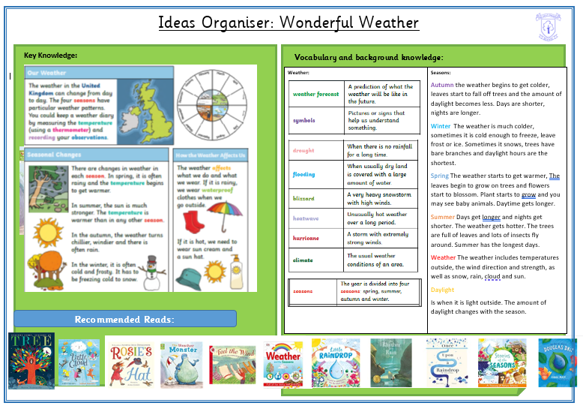
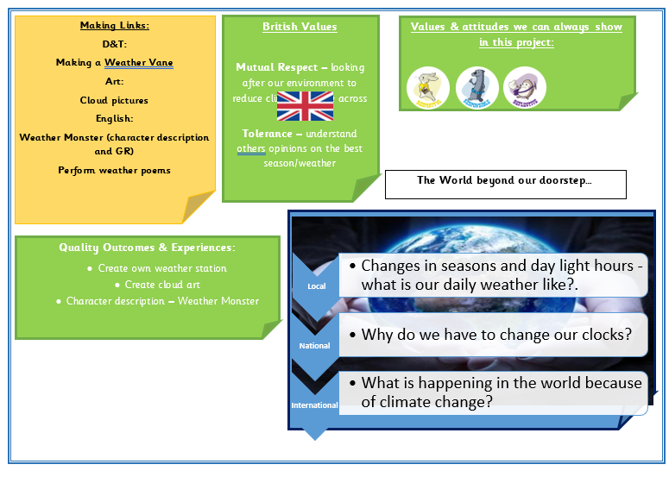
Year 1
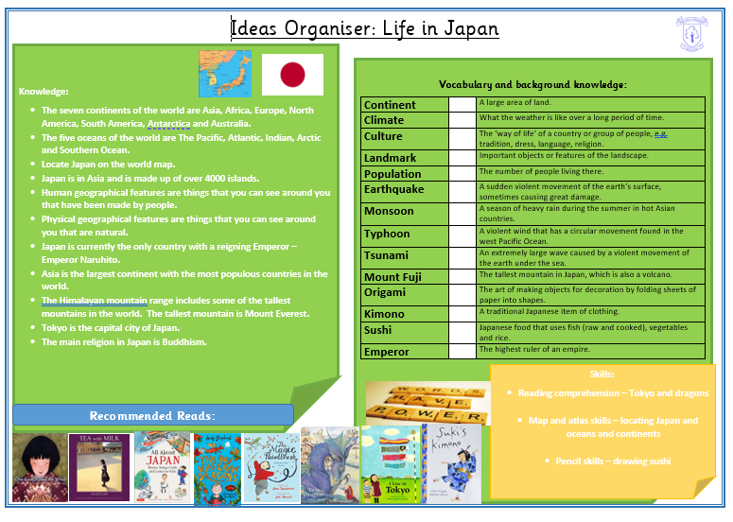
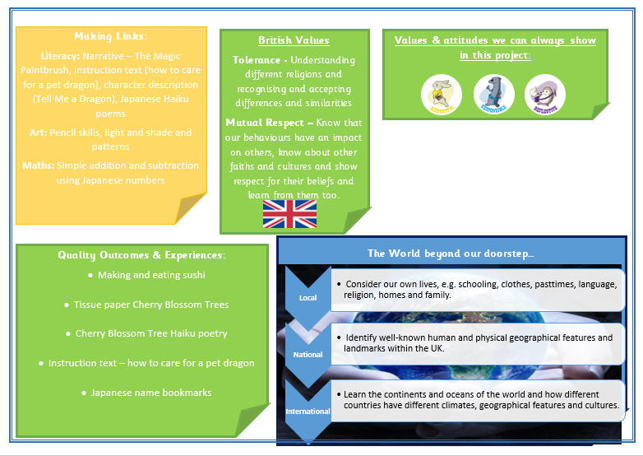
Year 2

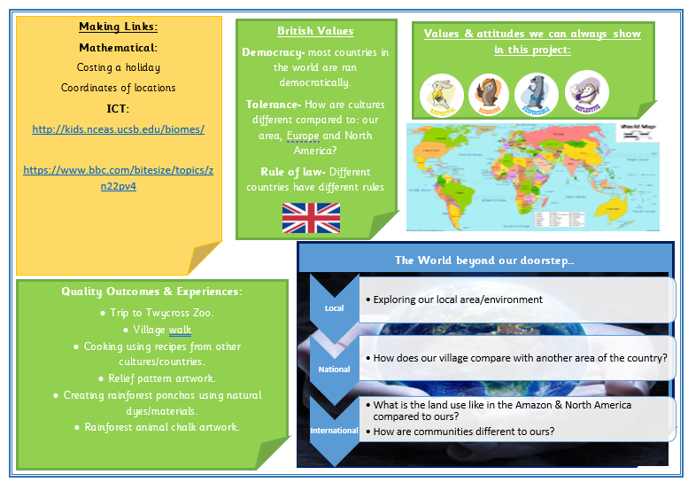
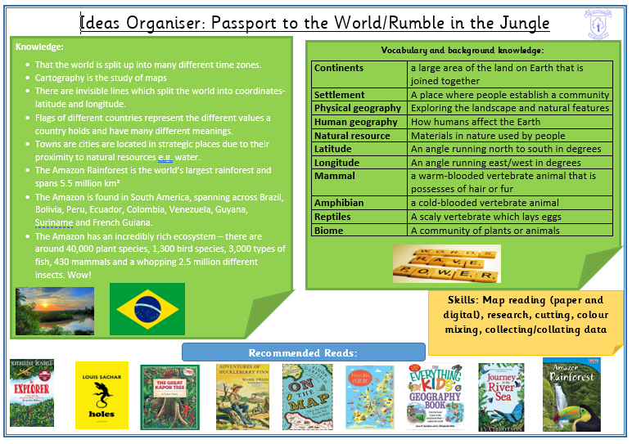
Year 5/6 Cycle A
Links to developing English and Maths

Geography makes a significant contribution to the teaching of Literacy in our school because
it actively promotes the skills of reading, writing, speaking and listening. We focus on the
key vocabulary of the subject and use knowledge organisers to support our writing.
Children are provided with opportunities to write at length in geography with the aim of
showing consistency in writing across all subjects.
Our field work investigations develop data handling and graphing skills. The spatial
dimension of map-work is mathematical, too, through direction and locational work.
Our map work develops ability to understand and use co-ordinates. It also develops
understanding of compass points and provides opportunity for them to practise giving
directions using a compass.

Assessment

A new approach to assessment is currently being trialled. This includes the following:

- Learning flashbacks to help pupils retrieval of prior learning in the subject from previous year groups.
- Progress Pauses used as a mid-point check within a unit to check the learning that has taken place.
- End of unit assessment task – Trial of knowledge tracker grids.

