Pupil premium strategy statement

This statement details our school’s use of pupil premium (and recovery premium for the 2024 to 2025 academic year) funding to help improve the attainment of our disadvantaged pupils.

It outlines our pupil premium strategy, how we intend to spend the funding in this academic year and the effect that last year’s spending of pupil premium had within our school.

School overview
Detail | Data
School name | Holt Primary School
Number of pupils in school | 196
Proportion (%) of pupil premium eligible pupils | 15%
Academic year/years that our current pupil premium strategy plan covers (3 year plans are recommended) | Sept 24 – July 27
Date this statement was published | Dec 2024
Date on which it will be reviewed | Dec 2025 and Dec 2026
Statement authorised by | Julie Leach - Head
Pupil premium lead | Julie Leach - Head
Governor / Trustee lead
Funding overview
Detail | Amount
Pupil premium funding allocation this academic year | £47,360
Recovery premium funding allocation this academic year | £2,393
Pupil premium funding carried forward from previous years (enter £0 if not applicable) | £0
Total budget for this academic year  If your school is an academy in a trust that pools this funding, state the amount available to your school this academic year | £ 49,753

Part A: Pupil premium strategy plan

Statement of intent
At The Holt Primary School, we have high expectations for all pupils within our setting, irrespective of their background or the challenges they face, and deliver a curriculum that enables them to make good progress and achieve high attainment across all subject areas. We believe that with high quality teaching and engagement with parents and outside agencies, including pastoral support, we can empower all out children to reach their potential. We can provide a personalised approach to meet individual needs academically, socially and emotionally.
The strategies implemented enable us to meet the needs of those children in receipt of Pupil Premium, including progress for those who are already high attainers. The focus of our pupil premium strategy is to support disadvantaged pupils to achieve that goal and aim that these children do as well as their peers with a similar starting point who are not eligible.
We will consider the challenges faced by vulnerable pupils, such as those who have a social worker and young carers. The activity outlined within this statement is also intended to support their needs, regardless of whether they are disadvantaged or not.
High-quality teaching is at the heart of our approach, with a focus on areas in which disadvantaged pupils require the most support. Within every lesson, there is an increased focus on supporting those children with the areas in which they need the most support. This is proven to have the greatest impact on closing the attainment gap and at the same time will benefit the non-disadvantaged pupils in our school. It is the aim of our school that non-disadvantaged pupils’ attainment will be sustained and improved alongside progress for their disadvantaged peers to enable all pupils to catch up.
Our strategy is also integral to wider school plans for education recovery, notably in its targeted support through tutoring and small group intervention for pupils whose education has been worst affected, including non-disadvantaged pupils.
Funding is allocated within the financial year and our approach will be responsive to common challenges and individual needs, based on our own data analysis and by making use of the EEF current research. This allows us to plan how we will support pupils strategically year on year.

The approaches we have adopted complement each other to help pupils excel. To ensure they are effective we will:
- ensure disadvantaged pupils are challenged in the work that they’re set
- act early to intervene at the point need is identified
- adopt a whole school approach in which all staff take responsibility for disadvantaged pupils’ outcomes and raise expectations of what they can achieve

Challenges

This details the key challenges to achievement that we have identified among our disadvantaged pupils.
Challenge number | Detail of challenge
1 | Assessments, observations, and discussions with pupils indicate weaker oral language skills and vocabulary gaps among some pupils, including disadvantaged pupils. These include speech and language difficulties and a lack of exposure to wider vocabulary. These are evident in our youngest pupils, especially Reception and KS1 and is an impact of lack of social interaction during the pandemic. In general, these are more prevalent among our disadvantaged pupils than their peers.
2 | Assessments, observations, and discussions with pupils suggest disadvantaged pupils generally have greater difficulties with phonics than their peers. This negatively impacts their development as readers.
3 | Internal and external (where available) assessments indicate that maths attainment among disadvantaged pupils is significantly below that of non-disadvantaged pupils with a particular weakness in core maths skills, vocabulary and application of calculation to problem solving and reasoning activities.
4 | Internal and external (where available) assessments indicate that reading attainment among disadvantaged pupils is significantly below that of non-disadvantaged pupils with a particular weakness in fluency and decoding impacting on comprehension and recall
5 | Our assessments and observations indicate that the education and wellbeing of many of our disadvantaged pupils have been impacted by partial school closures to a greater extent than for other pupils. This has resulted in children not being socially and emotionally ready to access learning demonstrated by poor motivation, self-belief and stamina. This can impact on their ability to focus and do well with their learning. These findings are supported by national studies.

Intended outcomes
This explains the outcomes we are aiming for by the end of our current strategy plan, and how we will measure whether they have been achieved.
Intended outcome | Success criteria
Improved oral language skills and vocabulary among disadvantaged pupils. | Assessments and observations indicate significantly improved oral language among disadvantaged pupils. This is evident when triangulated with other sources of evidence, including engagement in lessons, book scrutiny and ongoing formative assessment.  Key vocabulary development is a key feature of all curriculum plans  Opportunities for language development; discussing texts, debates, conversations for different purposes are included in all year groups
Improved phonics and reading attainment amongst our youngest pupils EYFS, Y1 and y2 | RWI, DFE validated phonics programme, is taught with fidelity, the children are tracked and assessed regularly and intervention is in place for children not making sufficient progress  Resources to support home reading, matched to in school phonics teaching are in place  Assessments and observations at the end of year 1 show phonics outcomes for disadvantaged pupils are improving  KS1 reading outcomes show an increased % of disadvantaged pupils have met the expected standard
Improved maths attainment for disadvantaged pupils at the end of KS2 | KS2 maths outcomes in 24/25 show that more than 50% of disadvantaged pupils have met the expected standard
Improved reading attainment for disadvantaged pupils at the end of KS2 | Pupils make good progress in reading as a result of the consistent implementation of the approach to reading across school  High quality and varied texts are available for pupils that match their ability and interests  Pupils engage with a widening variety of texts and books and have regular opportunities to change them  An increase % of PP pupils are working at ARE or above across the school in reading
To achieve and sustain improved wellbeing for all pupils in our school, particularly our disadvantaged pupils. Ensure we provide a safe and nurturing environment for our pupils by providing additional support for pupils wellbeing and anxiety, ensuring learning behaviours and conduct reflect our high expectations | Sustained high levels of wellbeing  - qualitative data from student voice, student and parent surveys and teacher observations  - UKS2 are ready and prepared for secondary school  - Staff are able to intervene before external support is needed with a range of strategies

Activity in this academic year
This details how we intend to spend our pupil premium (and recovery premium funding) this academic year to address the challenges listed above.

Teaching (for example, CPD, recruitment and retention)
Budgeted cost: £3400
Activity | Evidence that supports this approach | Challenge number(s) addressed
Continue to work with a Specialist Teacher with access to standardised diagnostic tests as well as use of NFER  SENCO meet with staff to ensure assessments are interpreted correctly and provision in put in place to meet targets set | Standardised tests can provide reliable analysis of the specific strengths and weaknesses and areas of need. This can help ensure they receive additional support through interventions or teacher instruction, provision, resources or programmes to aid development  https://educationendowmentfoundation.org.uk/tools/assessing-and-monitoring-pupil-progress/testing/standardised-tests | 1,2,3,4,6
Purchase a range of resources to support the teaching of phonics via DFE validated scheme including subscriptions to training materials and appropriate decidable material at home and school to secure stronger phonics teaching for all pupils | Evidence indicates that teaching a synthetic phonics programme systematically and with fidelity has a positive approach on word reading, understanding of phoneme and graphemes and supports the early development of reading  https://educationendowmentfoundation.org.uk/education-evidence/teaching-learning-toolkit/phonics  https://www.gov.uk/government/publications/choosing-a-phonics-teaching-programme | 1,2,4
Continue to develop opportunities for discussion across the curriculum to help pupils articulate ideas, consolidate understanding and develop vocabulary | Oral language interventions such as classroom discussions after reading a high-quality text are effective, easy to implement and has a high impact on reading  https://educationendowmentfoundation.org.uk/education-evidence/teaching-learning-toolkit/oral-language-interventions | 1,4
Enhancement of our maths teaching and curriculum in line with DFE and EEF guidance. Funding for teacher release to embed key elements in school and access Maths Hub resources and CPD including Maths Mastery and Numbots | The DfE non-statutory guidance has been produced in conjunction with the National Centre for Excellence in the Teaching of Mathematics, drawing on evidence-based approaches:  Mathematics guidance: key stages 1 and 2 (covers years 1 to 6) (publishing.service.gov.uk)  The EEF guidance is based on a range of the best available evidence:  https://educationendowmentfoundation.org.uk/education-evidence/guidance-reports/maths-ks-2-3 | 3,6

Targeted academic support (for example, tutoring, one-to-one support structured interventions)
Budgeted cost: £ 42,00
Activity | Evidence that supports this approach | Challenge number(s) addressed
Additional phonics teaching to ensure all children are in appropriate groups and ‘catch up’ interventions are in place and delivered by trained staff in association with the English Hub | There is evidence that indicates phonics teaching in small groups and one to one can have a positive impact on pupils. Targeted interventions develop decoding skills more quickly, particularly those from disadvantaged backgrounds.  https://educationendowmentfoundation.org.uk/education-evidence/teaching-learning-toolkit/phonics | 2
Careful deployment of additional adults in the classroom allows for targeted teaching of small groups with specific needs and will accelerate the progress of disadvantaged groups and others with identified needs | Evidence suggests that small group tuition is most likely to be effective if it is targeted as pupils specific needs and can also be used as a more general strategy to ensure progress or teach challenging skills or topics.  https://educationendowmentfoundation.org.uk/education-evidence/teaching-learning-toolkit/small-group-tuition | 2,3,4,6
High quality, structured, evidence based interventions, delivered by highly competent Learning Support Assistants, to address barriers to learning. Including: phonics - RWI reading fluency and numberstacks will be strategically deployed to need through data analysis | Targeted small group intervention based on a specific barriers to learning can be an effective method in supporting pupils to fill these gaps and make progress.  EEF research- effective use of teaching assistants recommendation 5.  Making Best Use of Teaching Assistants | EEF (educationendowmentfoundation.org.uk)  This is also a proven strategy within school.  Evidence from Education Endowment Foundation – ‘Teaching and Learning Toolkit’: Individualised instruction + 4 months  Individualised instruction | EEF (educationendowmentfoundation.org.uk)  Small group tuition +4 months  Small group tuition | EEF (educationendowmentfoundation.org.uk) | 2,3,4,6
Additional qualified teacher to enhance ratio and identify specific learning barriers in relation to reading fluency in UKS2 and mathematics and to plan and implement intervention to support progress | It is well known that if pupils are not fluent readers, then they cannot comprehend. This strategic approach is in place to ensure that all pupils leave our school as competent and fluent readers who are able to comprehend. Evidence from EEF –Improving Literacy KS2.  Improving Literacy KS2  Improving Literacy in Key Stage 2 | EEF (educationendowmentfoundation.org.uk)  The EEF guidance is based on a range of the best available evidence:  https://educationendowmentfoundation.org.uk/education-evidence/guidance-reports/maths-ks-2-3 | 3,4

Wider strategies (for example, related to attendance, behaviour, wellbeing)
Budgeted cost: £ 4000
Activity | Evidence that supports this approach | Challenge number(s) addressed
Intervention from external behavioural agency to support pupil well being and anxiety including support and training for staff to deliver strategies in school | This is a proven support system in school that is well established and plays an essential part in supporting our pupils during the pandemic and on return to school and at other challenging times in their life  Social and emotional learning | EEF (educationendowmentfoundation.org.uk) | 5
Embedding principles of good practice set out in the DfE’s Improving School Attendance advice. There are one or two pupils where attendance and punctuality need to improve. The school will continue to work closely with these families | The DfE guidance has been informed by engagement with schools that have significantly reduced levels of absence and persistent absence.  Improving school attendance: support for schools and local authorities - GOV.UK (www.gov.uk)

Total budgeted cost: £ 50,000

Part B: Review of outcomes in the previous academic year

Pupil premium strategy outcomes
This details the impact that our pupil premium activity had on pupils in the 2023-24 academic year.
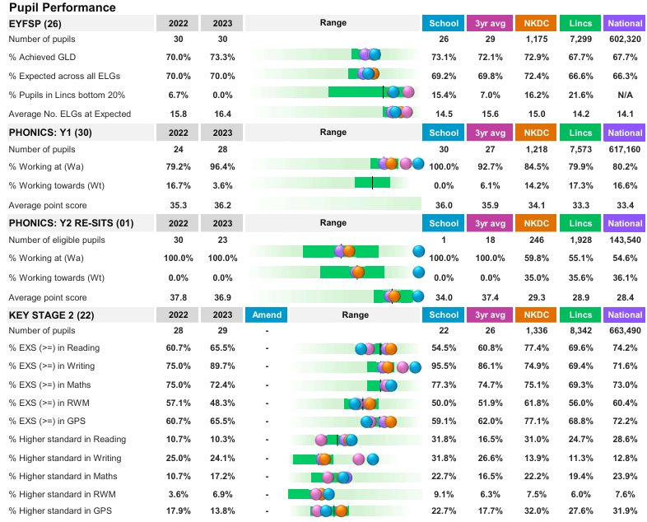
Out GLD in reception was 73.1% which was above local and national averages. The use of WELLCOMM assessments and intervention saw significant increases in speaking and listening from the September baselines. 95% of the reception class ended the year at or above where they should be for RWI.
Phonics screening was 100% in year 1 and year 2. RWI is well established and reading for pleasure is embedded across the whole school.
Phonics teaching remains a priority and support from RWI ensures that children made good progress from their starting points and catch up is accessible when needed to accelerate progress in the form of 1:1 support.
Small group intervention took place for maths using the number stacks programme In year 6, 71% of PP pupils achieved the expected standard. This cohort had the most disrupted Key stage 2 due to the pandemic and internal staffing issues.
The development of reading fluency was impacted upon by the purchase of high quality reading materials, supporting children’s interests and promoting a love of reading. Decodable texts to support the phonics scheme used for home reading supported the development in phonics seen above and meeting reading expectations.
Our assessments and observations indicated that well being and mental health continue to rise. Providing 1:1 intervention with an external provider to support emotional needs and anxiety issues has enabled pupils to be more ready for learning and access the curriculum as they deploy strategies they have learned during leaning and social aspects of the school day. This nurturing approach, supporting parents with ideas and strategies too has seen an improvement in motivation and stamina as well as confidence and self esteem. Communication between teachers, parents and the emotional and behavioural specialist has enabled these children to navigate difficult circumstances and thrive and will continue to be built upon.
The introduction of C-POMS allows quicker identification of patterns of behaviour and quicker responses to concerns so appropriate intervention can be given.
Access to trips and residentials was supported for all PP pupils.

Externally provided programmes
Please include the names of any non-DfE programmes that you purchased in the previous academic year. This will help the Department for Education identify which ones are popular in England
Programme | Provider
Not applicable

