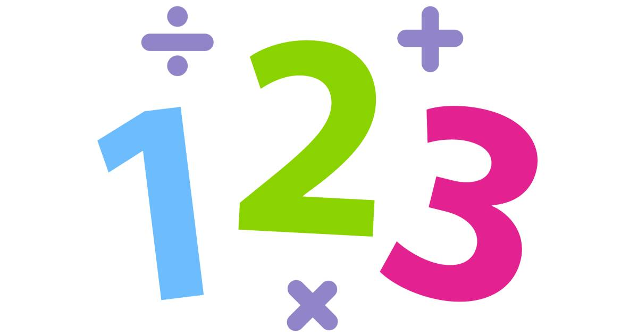

Maths Curriculum
Intent

When teaching mathematics at The Holt, we intend to use a variety of teaching methods and resources that allow all pupils equal access to mathematics and to experience success and enjoyment. Over time, children will become resilient learners who are able to accept that to struggle is a necessary step in their learning. Children will be appropriately challenged and supported through varied fluency, reasoning and problem solving. Irrespective of personal starting points, children will explore maths in depth, and use a range of mathematical vocabulary to reason and explain. Pupils will persevere by building on previous knowledge and skills, and apply these to a wide variety of contexts both within maths and across the curriculum. They will appreciate the relevance of maths in real life situations, recognising that it is not simply ‘sums’ and ‘rules’.
Decisions about when to progress should always be based on the security of pupils’ understanding and their readiness to progress to the next stage. Pupils who grasp concepts rapidly should be challenged through being offered rich and sophisticated problems before any acceleration through new content. Those who are not sufficiently fluent with earlier material should consolidate their understanding, including through additional practice, before moving on.

Implementation

The implementation of our curriculum is developed through secure knowledge and understanding of the curriculum and subject area. Pupils in Foundation Stage will access their maths learning through continuous provision. Mathematical concepts are introduced and built upon through a series of direct teaching sessions. Within the provision, children have the freedom to further explore these mathematical concepts through concrete resources and creative opportunities. In addition to this, they are encouraged to follow their own mathematical lines of enquiry, which are supported through effective adult modelling and interactions. Past skills are reinforced through the ‘Take 5’ approach and 1-1/small group work is used to further develop skills. Layered success criteria, in Y1 through to Y6, is used to encourage and support children’s development of metacognition and to motivate them to challenge themselves within a concept. Maths lessons are planned and delivered in accordance with White Rose Maths’ small steps progression, which is underpinned by the concrete, pictorial & abstract (CPA) approach.
Planning:
Long Term: White Rose Maths overviews
Medium Term: White Rose small steps document which breaks down objectives into blocks.
Short Term: Daily lessons which include: 5 a day element to refine calculation skills; a reading for maths section (once a week) to break down mathematical language and unpick problems; opportunities to develop fluency, reasoning and problem solving.
The school is driving forward strategies based on reasoning and problem solving; resources have been purchased to aid in the development of this: Classroom Secrets, new White Rose materials, Testbase. The maths leads are also undertaking a teaching for mastery course, which incorporates a workgroup. Teaching for mastery is beginning to be implemented across all year groups.
All teachers:
1. ‘Know where their children are’ through the use of concise summative assessment, prior learning or assessment
2. ‘Understand where their children need to be’ through a secure understanding of year group expectations and/or pre key stage expectations and incisive, ongoing, formative assessment
3. ‘Know how they are going to get them there’ through the use of a range of strategies to promote independence, mastery and high expectations of ALL.
4. Effectively deploy adults, specifically during 5 a day and main activities.
5. Plan for progression during and between lessons.
Lessons across the school within Maths will include:
- Take 5/ 5 a day/Fast fifteen calculation fluency as part of a maths/skills lesson.
- One of the 5 a day lessons will allow the children to comprehend maths questions and unpick language/vocabulary in order to access the question.
- Lessons allow the children to explore concepts with their teacher demonstrating first, having a go together and then working independently.
- Most children will tackle the same learning with resources such as manipulatives and teacher support.
- A balance of fluency, reasoning and problem solving in lessons so that the children are able to secure good progress against the objectives. Fluency tasks are varied to allow children to see a concept in a multitude of different ways.
- Children’s thoughts are challenged through reasoning activities so that they can articulate their understanding.

There will also be other opportunities for the children to apply their knowledge and understanding of mathematics through their science/topic lessons e.g. converting distances, ordering sizes of countries etc.
Weekly homework reinforces all key concepts taught and includes multiplication homework to secure the mathematical fundamentals.
Knowledge organisers: As a school, we recognise the importance of developing a rich vocabulary so that children are able to not only understand new concepts but articulate them. At the start of each unit, a knowledge organiser is given with key language, which the children will need in order to be successful in the current unit. Language is also reinforced through display and explicit teaching points in lessons.Multiplication Tables:
Please see appendix 1 for information on the teaching of multiplication tables across the school. This approach is used so that all children are able to achieve the standard by the end of Year 4.

Daily teaching of multiplication tables takes place in KS2.
Times Table Rockstars is used to support the teaching and learning of multiplication tables. All teachers in KS2 follow the programme for the teaching of multiplication tables systematically.

Number Bonds: From EYFS, the children are taught number bonds with children having the opportunity in daily lessons in Y1 to reinforce these concepts through a tried and tested scheme. The children work their way through the scheme and explore: Number bonds, near doubles, doubles, adding 1, adding 2, bridging and bonds to 100. This scheme ends when the children are secure in their learning.

We recognise that quality first teaching in maths is the essential first step in improving outcomes for all children. With this in mind, we ensure that teachers and teaching assistants are kept up to date on the latest initiatives and news. This is through continuous professional development by outside providers and within school.

Progression of Knowledge and Skills in Mathematics linked to White Rose Maths:
See appendix 2.

Impact

Mastery for Maths (Maths Pedagogy):
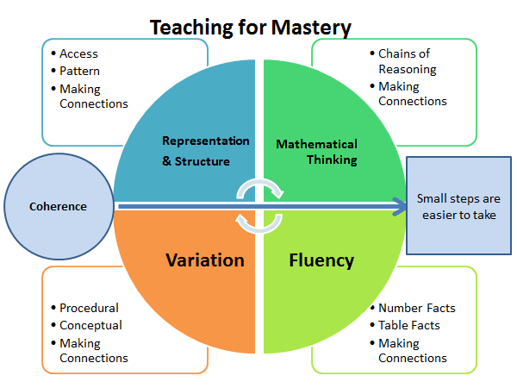

At the end of their mathematical education in this school, we expect students to:
Perform basic numeracy skills fluently
Understand the mathematics likely to be encountered in daily life
Reason clearly and logically, and to set out rational arguments
Approach problems systematically and choose appropriate techniques for their solution
Experience satisfaction in and enjoyment of mathematical experiences and achievements
Develop fluency in performing key mathematical skills so they become second nature.
Reason mathematically, think logically and flexibly to develop sound mathematical arguments.
Be prepared for the next stage of their education.
Solve problems in a diverse range of situations.

The impact of our curriculum will not only be measured by assessment procedures which allow us to measure outcomes against all schools nationally:
• EYFS % of pupils achieving a ‘Good level of development’ (GLD)
• Phonics Screening Test at the end of Year 1
• End of KS1 % of children working towards or at the expected standard and at Greater depth in reading, writing and maths
• End of Year 4 Multiplication Check.
• End of KS2 % of children working towards or at the expected standard and at Greater depth in reading, writing and maths.
But, will in fact be measured by how effectively it helps our pupils develop into well rounded individuals who embody our values and carry with them the knowledge, skills and attitudes which will make them lifelong learners and valuable future citizens.

Intervention
For those children who are working in the bottom 20%, timely interventions are given in short sessions across the school week so that progress can be made in relation to key skills. We choose to use Numberstacks in order to deliver this intervention. This is monitored both by the class teacher and the maths leaders who meet regularly to discuss the progress of the children. In Year 6, children have additional support through booster sessions.

Assessment:
White Rose end of block assessments with GAP analysis
NFER assessments to benchmark against other children nationally
SATs Y2/Y6.
End of unit assessments from White Rose are used to support teacher assessments, and end of term assessments are used to track progress and to identify knowledge that has not been well retained. Outcomes from both end of unit and end of term assessments are used to identify gaps in knowledge and will inform future planning. Pupil progress will also identify precise actions and objectives for targeted focus children, including the lowest 20% who are not likely to meet end of year expectations and/or not making expected progress.

Moderation:
In house
Peer review group moderation

Teaching of multiplication tables and number bonds:
Teaching of multiplication tables takes place in KS2.
Times Table Rockstars is used to support the teaching and learning of multiplication tables. All teachers in KS2 follow the programme for the teaching of multiplication tables systematically.

Number Bonds: Children are taught number bonds with children having the opportunity in daily lessons in Y1 to reinforce these concepts through a tried and tested scheme. The children work their way through the scheme and explore: Number bonds, near doubles, doubles, adding 1, adding 2, bridging and bonds to 100. This scheme ends when the children are secure in their learning.

We recognise that quality first teaching in maths is the essential first step in improving outcomes for all children. With this in mind, we ensure that teachers and teaching assistants are kept up to date on the latest initiatives and news. This is through continuous professional development by outside providers and within school.

Progression of Knowledge and Skills in Mathematics linked to White Rose Maths:
See appendix 2.

