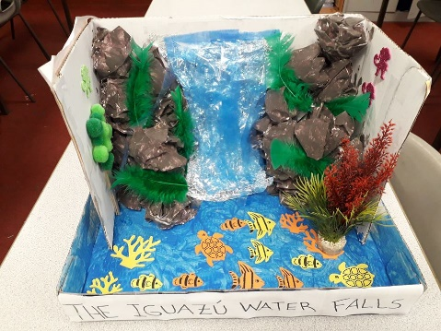**Year 3 Homework Project Spring Term**

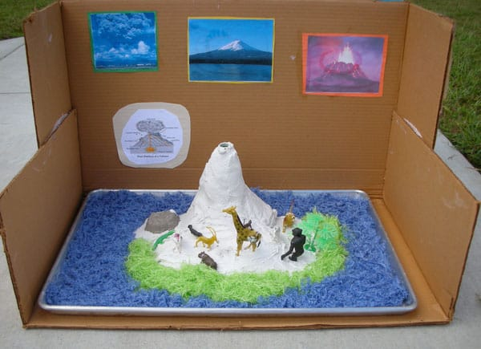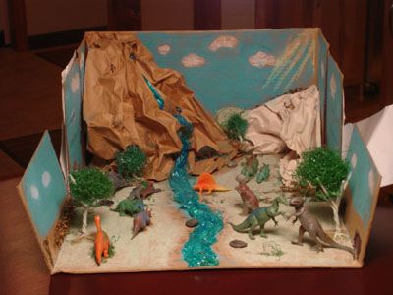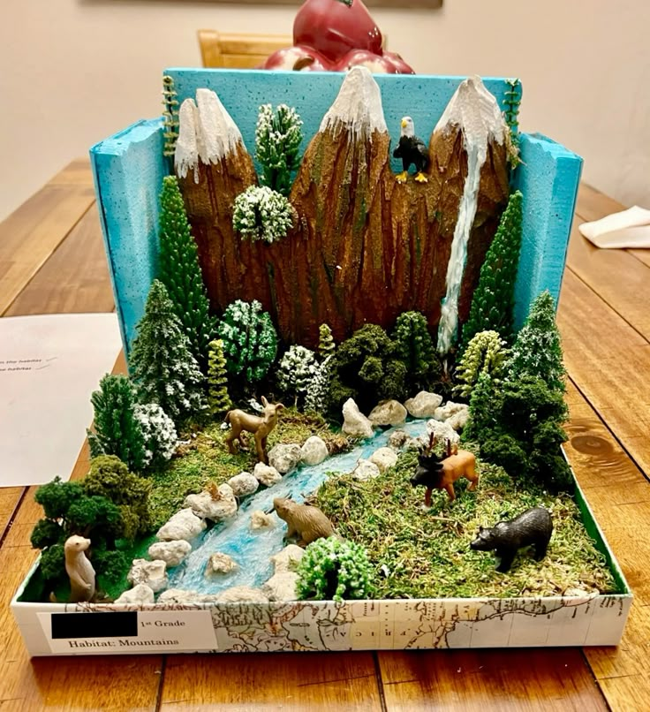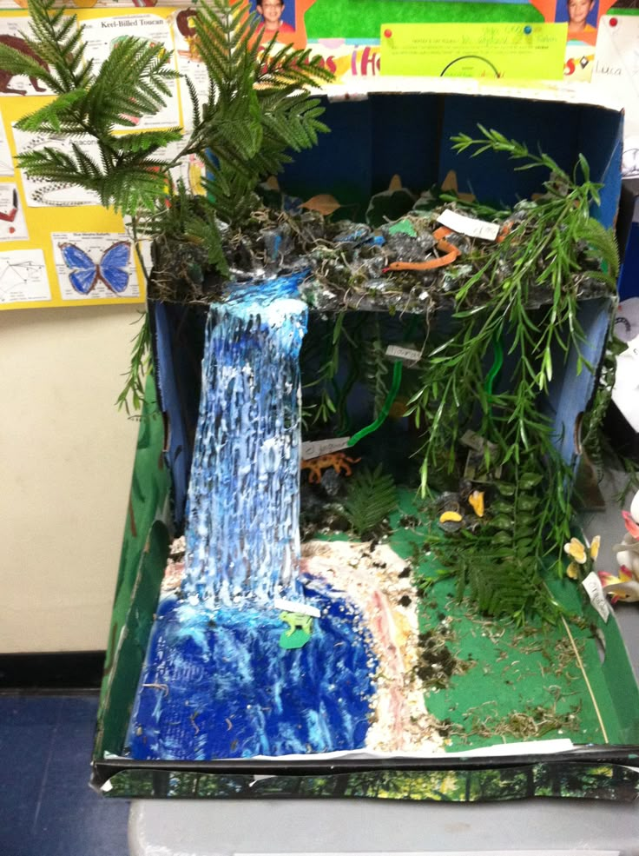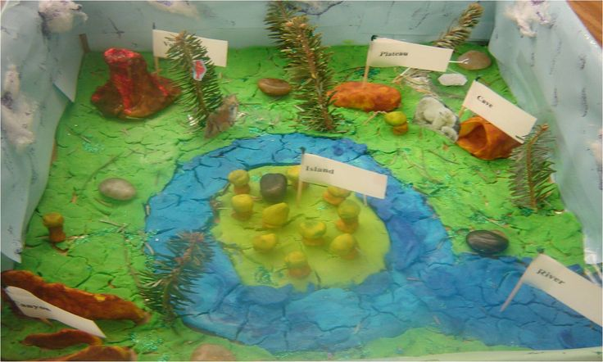**GEOGRAPHY IN A BOX!**

**Homework task**

**Date set: Friday 14th February**

**Hand in date : Friday 7th March**

**To link with our Geography work, I would like you to choose a famous river, mountain or volcano to find out about. This can be from anywhere in the world. Please research in a variety of ways and display your information creatively in a box no bigger than a small shoe box. Unfortunately, we do not have room in the classroom for large boxes. Be imaginative with your models and collage but please make sure you have *factual information* inside your box. I can’t wait to see the results of your creative hard work and I know you will love researching!**

**Mrs Thursby**